# OMS Certificate installation In WAS Console and Agents.

Please Use below steps for OMS Certificate installation.

**OMS Server List**

|  |  |  |
| --- | --- | --- |
| g1t4184.austin.hp.com | PRODUCTION | Sterling App 1 |
|  |  |  |
| g1t4185.austin.hp.com | PRODUCTION | Sterling App 2 |
|  |  |  |
| g2t3065.austin.hp.com | PRODUCTION | Sterling App 3 |
|  |  |  |
| g2t3066.austin.hp.com | PRODUCTION | Sterling App 4 |
|  |  |  |
| g1t4182.austin.hp.com | PRODUCTION | Sterling Agents 1 |
|  |  |  |
| g1t4183.austin.hp.com | PRODUCTION | Sterling Agents 2 |
|  |  |  |
| g2t3063.austin.hp.com | PRODUCTION | Sterling Agents 3 |
|  |  |  |
| g2t3064.austin.hp.com | PRODUCTION | Sterling Agents 4 |
|  |  |  |
| g1t1477g.austin.hp.com | PRODUCTION | Sterling HTTP 1 |
|  |  |  |
| g1t1956g.austin.hp.com | PRODUCTION | Sterling HTTP 2 |
|  |  |  |
| g2t2648g.austin.hp.com | PRODUCTION | Sterling HTTP 3 |
|  |  |  |
| g2t2650g.austin.hp.com | PRODUCTION | Sterling HTTP 4 |

**Steps to Add the certificate in WAS Below links.**

Log in to WAS -> SSL certificate and key management > Key stores and certificates > NodeDefaultTrustStore > Signer certificates

*Add certificate and Sync with nodes* .

|  |  |
| --- | --- |
|  | <https://g1t4184.austin.hp.com:9045/ibm/console>  <https://g1t4185.austin.hp.com:9043/ibm/console> |
|  | <https://g2t3065.austin.hp.com:9043/ibm/console>  <https://g2t3066.austin.hp.com:9043/ibm/console> |

PFS   
**Note:-- Signer certificate and personal certificate(Trust/Key) needs to be clarified with User story owner before implementing in Prod.**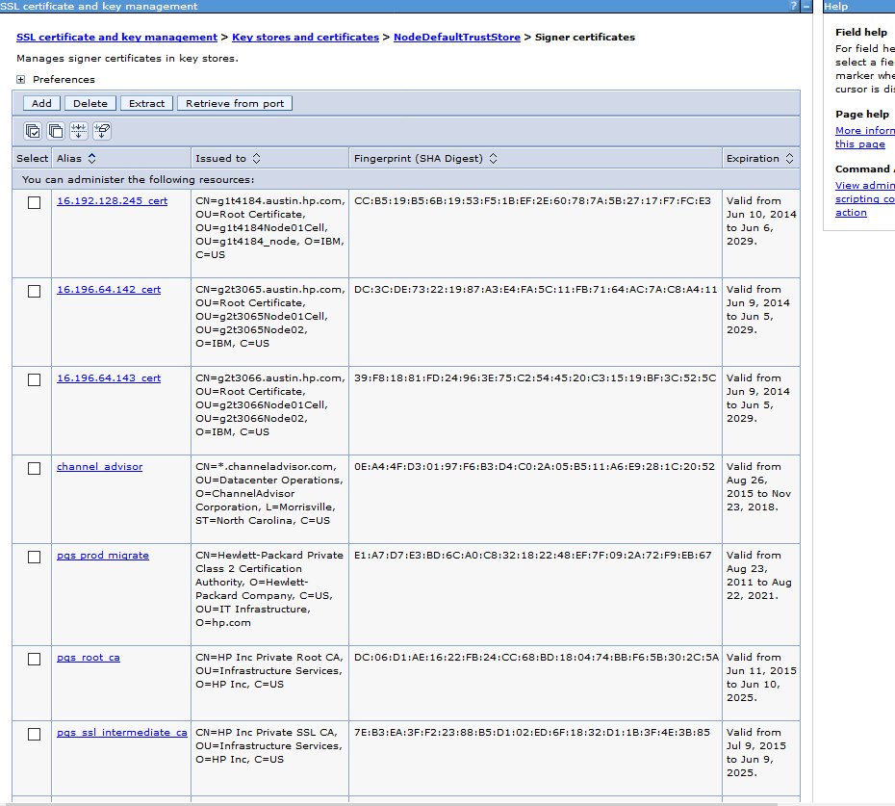  
**Restart the server in backend.**

**Then Implement the same in agent servers too.**  
Please follow below step’s for all agent servers:

1. Keep the backup of certificate in /tmp/ location with all user permissions to file and that location needs to be given in keytool command.

2. Take backup of **cacerts** in oms agent server in below location.

**/opt/apps/IBM/Sterling93/jdk/jre/lib/security/**



3. Go to **/opt/apps/IBM/Sterling93/jdk/jre/bin** and execute below command

keytool -import -alias hpca2016 -keystore /opt/apps/IBM/Sterling93/jdk/jre/lib/security/cacerts -trustcacerts -file /tmp/HP_Inc_Private_Root_CA.cer -storepass changeit

Give “**yes**” while asking confirmation then certificate will be added

4.Again execute below command to get message like *Certificate already exists*

keytool -import -alias hpca2017 -keystore /opt/apps/IBM/Sterling93/jdk/jre/lib/security/cacerts -trustcacerts -file /tmp/HP_Inc_Private_SSL_CA.509.pem -storepass changeit.

5.Check datestamp for update happened in cacerts file in all agent servers.

**\*\*\*\*\*\*\*\*\*\*\*\*\*\*\*\*\*\*\*\*\*\*\*\*\*\*\*\*\*\*\*\*\*\*\*\*\*\*\*On Request Only \*\*\*\*\*\*\*\*\*\*\*\*\*\*\*\*\*\*\*\*\*\*\*\*\*\*\*\*\*\*\*\*\*\*\*\*\*\*\*\*\*\*\*\***

If SSL handshake is experienced between agent server and application server , we will do this below request.

For SSL Change On Request only by client HP .  
Email Attached   


Step -1 – Change Protocol in Application servers, Follow below steps.

# [**SSL certificate and key management**](https://g1t4185.austin.hp.com:9043/ibm/console/navigatorCmd.do?csrfid=-659829420&forwardName=SecureCommunications.config.view&WSC=true) **>** [**Manage endpoint security configurations**](https://g1t4185.austin.hp.com:9043/ibm/console/com.ibm.ws.console.security.forwardCmd.do?csrfid=-659829420&forwardName=SecureEndpointTree.config.view&resourceUri=security.xml&parentRefId=Security_1&contextId=cells%3Ag1t4185Node01Cell&perspective=tab.configuration) **>** [**g1t4185_node**](https://g1t4185.austin.hp.com:9043/ibm/console/secureEndpointCollection.do?csrfid=-659829420&EditAction=True&name=g1t4185_node&parentRefId=Security_1&direction=inbound&mgmtScope=(cell):g1t4185Node01Cell:(node):g1t4185_node&type=node&perspective=tab.configuration) **>** [**SSL configurations**](https://g1t4185.austin.hp.com:9043/ibm/console/com.ibm.ws.console.security.forwardCmd.do?csrfid=-659829420&forwardName=SSLConfig.content.main&sfname=repertoire&resourceUri=security.xml&parentRefId=SSLConfigGroup_g1t4185_node_1&contextId=cells%3Ag1t4185Node01Cell&perspective=tab.configuration) **>** [**NodeDefaultSSLSettings**](https://g1t4185.austin.hp.com:9043/ibm/console/sSLConfigCollection.do?csrfid=-659829420&EditAction=true&refId=SSLConfig_g1t4185_node_1&contextId=cells%3Ag1t4185Node01Cell&resourceUri=security.xml&perspective=tab.configuration) **> Quality of protection (QoP) settings**

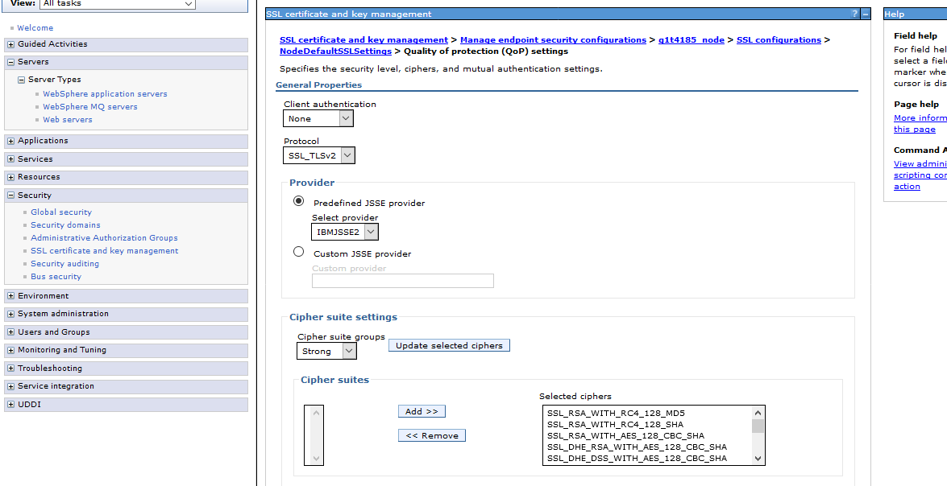

Step 2 . Change Protocol in Application server, before take backup of **ssl.client.props**

**ssl.client.props : change com.ibm.ssl.protocol from SSL_TLS to SSL_TLSv2** 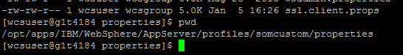

Step 3 : Change in Agent Server too and backup before doing it.

Add this property in **-Dhttps.protocols=SSL_TLSv2** in file **/opt/apps/IBM/Sterling93/bin/agentserver.sh**

**PFS**

AGENT_JAVA_OPTS="-Dvendor=shell -Xverbosegclog:/opt/apps/IBM/Sterling93/logs/agents/$1_$$_gc.log -verbose:gc -DvendorFile=/opt/apps/IBM/Sterling93/properties/servers.properties -DCACHE_PS=true -DDISABLE_DS_EXTENSIONS=Y -Duser.timezone=UTC -Dhttps.proxyHost=web-proxy.austin.hpicorp.net -Dhttps.proxyPort=8080 -Dhttps.protocols=SSL_TLSv2"

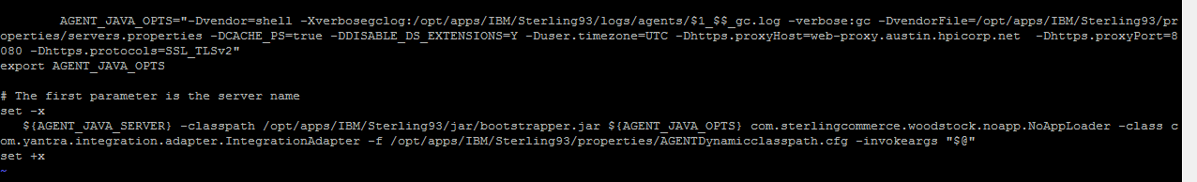

**=================================END====================================**